AlexNet — 5 conv layers
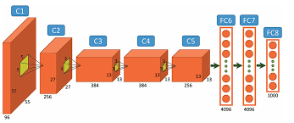
Architecture: Conv(11,s4) - Pool(3,s2) - Conv(5,s1) -Pool(3,s2) -Conv(3x3)

Layer | Type | k | s | jump | added | R (px)
start |  |  |  | 1 | — | 1
conv1_1 | Conv | 11 | 4 | 1 | (11-1)x1 = 10 | 11
pool1 | MaxPool | 3 | 2 | 4 | (3-1)x4 = 8 | 19
conv2_1 | Conv | 5 | 1 | 8 | (5-1)x8 = 32 | 51
pool2 | MaxPool | 3 | 2 | 16 | (3-1)x8 = 16 | 67
conv3_1 | Conv | 3 | 1 | 16 | (3-1)x16 = 32 | 99
conv3_2 | Conv | 3 | 1 | 16 | (3-1)x16 = 32 | 131
conv3_3 | Conv | 3 | 1 | 16 | (3-1)x16 = 32 | 163

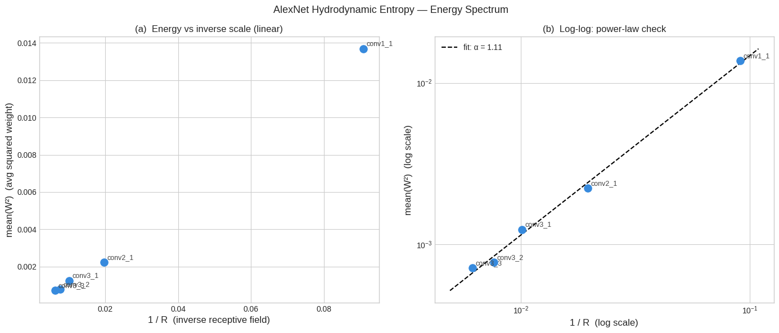
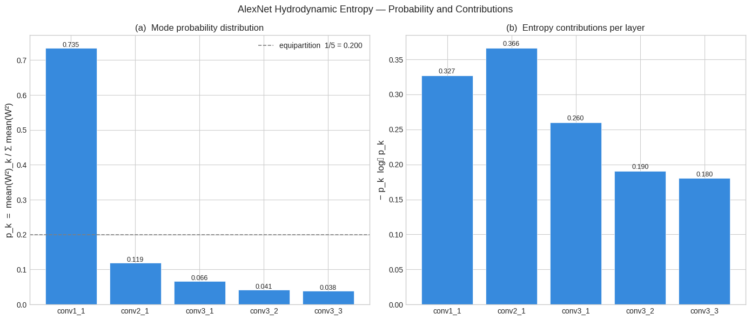
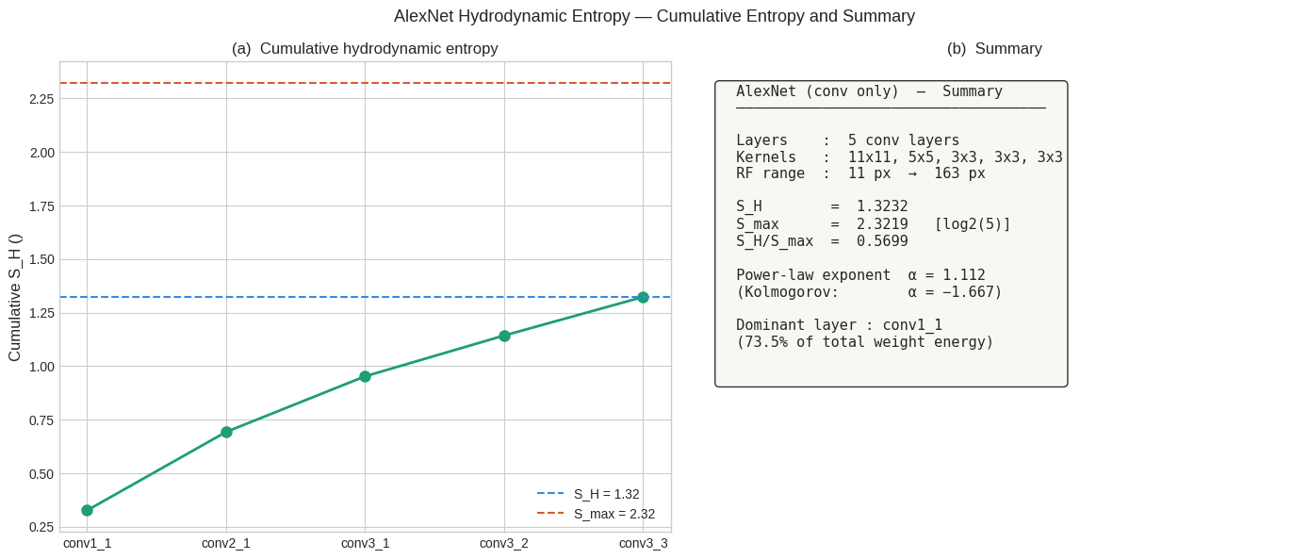

VGG-16 — 13 conv layers
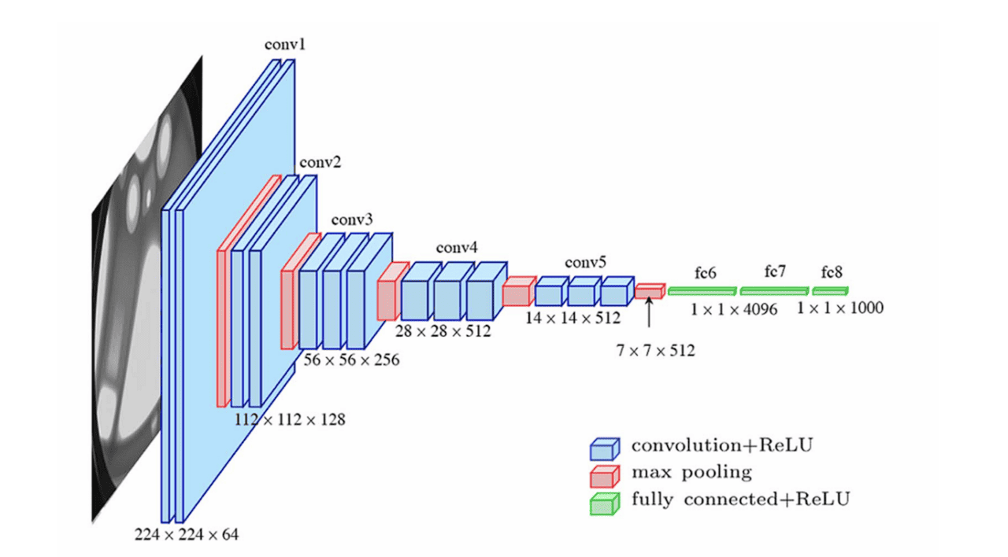
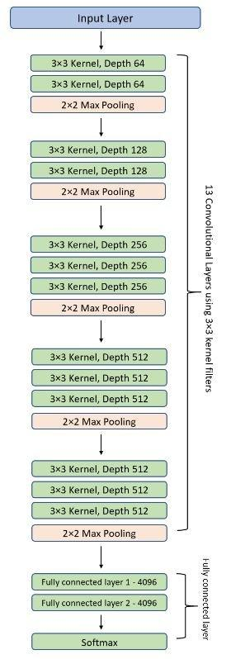

Architecture: 2 + 2 + 3 + 3 + 3 conv layers across 5 blocks, all 3x3 kernels, MaxPool(2,s2) between blocks

Layer | Type | k | s | jump | added | R (px)
start |  |  |  | 1 | — | 1
conv1_1 | Conv | 3 | 1 | 1 | (3-1)x1 = 2 | 3
conv1_2 | Conv | 3 | 1 | 1 | (3-1)x1 = 2 | 5
pool1 | MaxPool | 2 | 2 | 2 | (2-1)x1 = 1 | 6
conv2_1 | Conv | 3 | 1 | 2 | (3-1)x2 = 4 | 10
conv2_2 | Conv | 3 | 1 | 2 | (3-1)x2 = 4 | 14
pool2 | MaxPool | 2 | 2 | 4 | (2-1)x2 = 2 | 16
conv3_1 | Conv | 3 | 1 | 4 | (3-1)x4 = 8 | 24
conv3_2 | Conv | 3 | 1 | 4 | (3-1)x4 = 8 | 32
conv3_3 | Conv | 3 | 1 | 4 | (3-1)x4 = 8 | 40
pool3 | MaxPool | 2 | 2 | 8 | (2-1)x4 = 4 | 44
conv4_1 | Conv | 3 | 1 | 8 | (3-1)x8 = 16 | 60
conv4_2 | Conv | 3 | 1 | 8 | (3-1)x8 = 16 | 76
conv4_3 | Conv | 3 | 1 | 8 | (3-1)x8 = 16 | 92
pool4 | MaxPool | 2 | 2 | 16 | (2-1)x8 = 8 | 100
conv5_1 | Conv | 3 | 1 | 16 | (3-1)x16 = 32 | 132
conv5_2 | Conv | 3 | 1 | 16 | (3-1)x16 = 32 | 164
conv5_3 | Conv | 3 | 1 | 16 | (3-1)x16 = 32 | 196
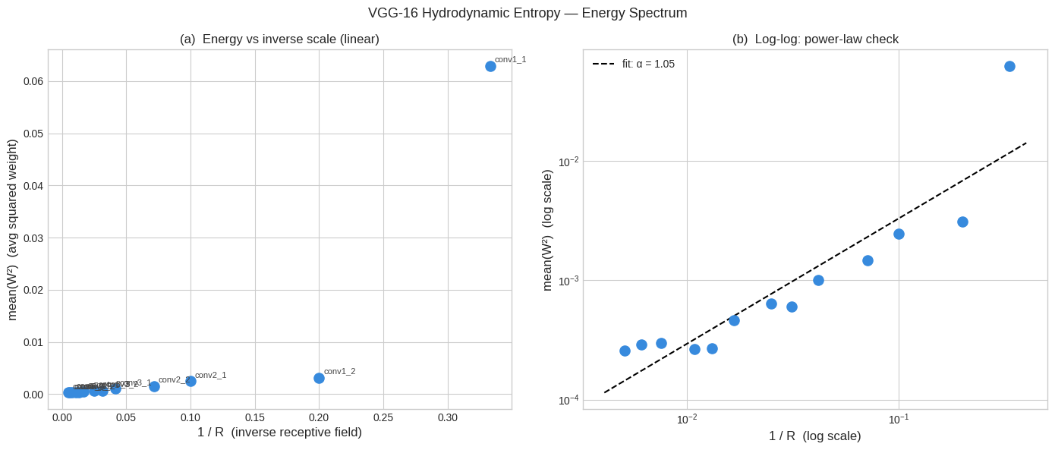
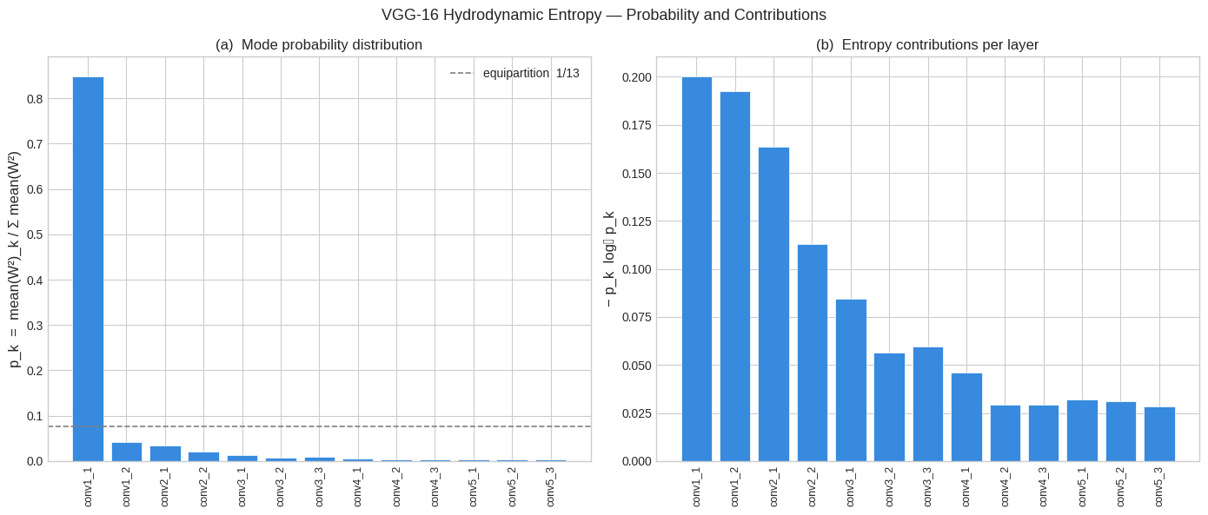
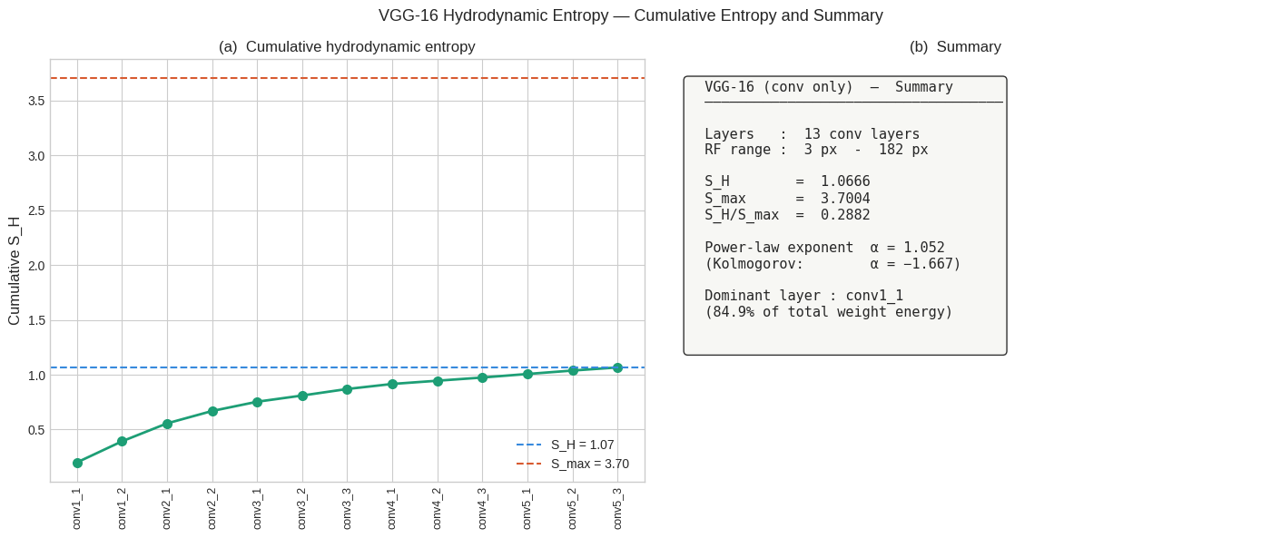

VGG-19 — 16 conv layers
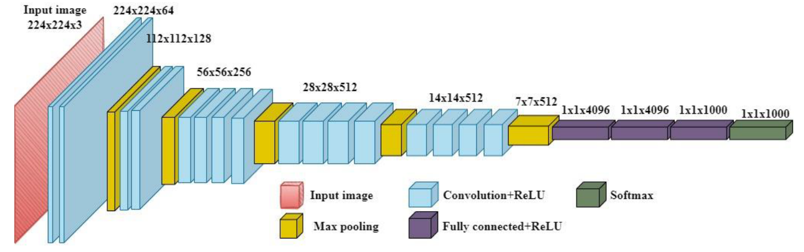

Architecture: 2 + 2 + 4 + 4 + 4 conv layers — blocks 3,4,5 each have one extra conv vs VGG-16

Layer | Type | k | s | jump | added | R (px)
start |  |  |  | 1 | — | 1
conv1_1 | Conv | 3 | 1 | 1 | (3-1)x1 = 2 | 3
conv1_2 | Conv | 3 | 1 | 1 | (3-1)x1 = 2 | 5
pool1 | MaxPool | 2 | 2 | 2 | (2-1)x1 = 1 | 6
conv2_1 | Conv | 3 | 1 | 2 | (3-1)x2 = 4 | 10
conv2_2 | Conv | 3 | 1 | 2 | (3-1)x2 = 4 | 14
pool2 | MaxPool | 2 | 2 | 4 | (2-1)x2 = 2 | 16
conv3_1 | Conv | 3 | 1 | 4 | (3-1)x4 = 8 | 24
conv3_2 | Conv | 3 | 1 | 4 | (3-1)x4 = 8 | 32
conv3_3 | Conv | 3 | 1 | 4 | (3-1)x4 = 8 | 40
conv3_4 | Conv | 3 | 1 | 4 | (3-1)x4 = 8 | 48
pool3 | MaxPool | 2 | 2 | 8 | (2-1)x4 = 4 | 52
conv4_1 | Conv | 3 | 1 | 8 | (3-1)x8 = 16 | 68
conv4_2 | Conv | 3 | 1 | 8 | (3-1)x8 = 16 | 84
conv4_3 | Conv | 3 | 1 | 8 | (3-1)x8 = 16 | 100
conv4_4 | Conv | 3 | 1 | 8 | (3-1)x8 = 16 | 116
pool4 | MaxPool | 2 | 2 | 16 | (2-1)x8 = 8 | 124
conv5_1 | Conv | 3 | 1 | 16 | (3-1)x16 = 32 | 156
conv5_2 | Conv | 3 | 1 | 16 | (3-1)x16 = 32 | 188
conv5_3 | Conv | 3 | 1 | 16 | (3-1)x16 = 32 | 220
conv5_4 | Conv | 3 | 1 | 16 | (3-1)x16 = 32 | 252

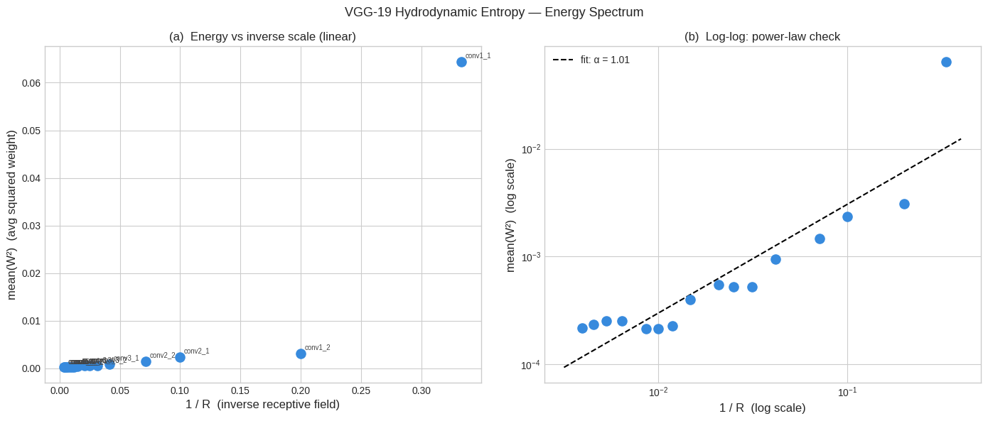
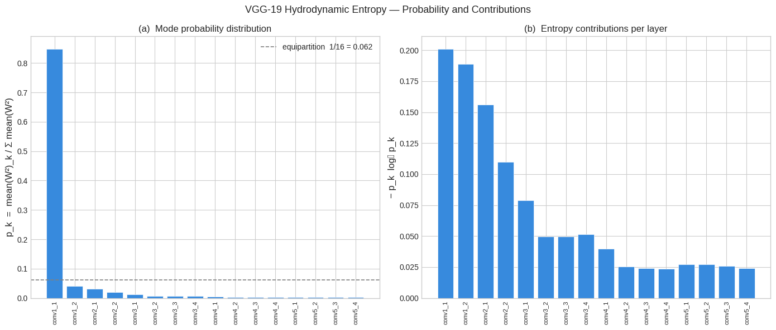
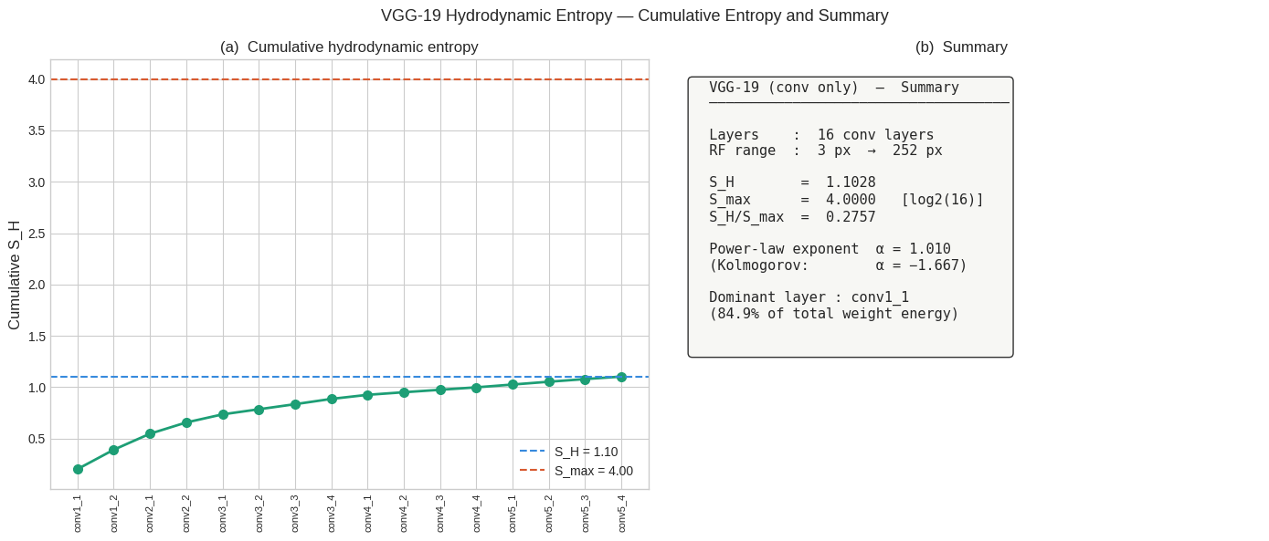

Graphcast:
GC_Full:
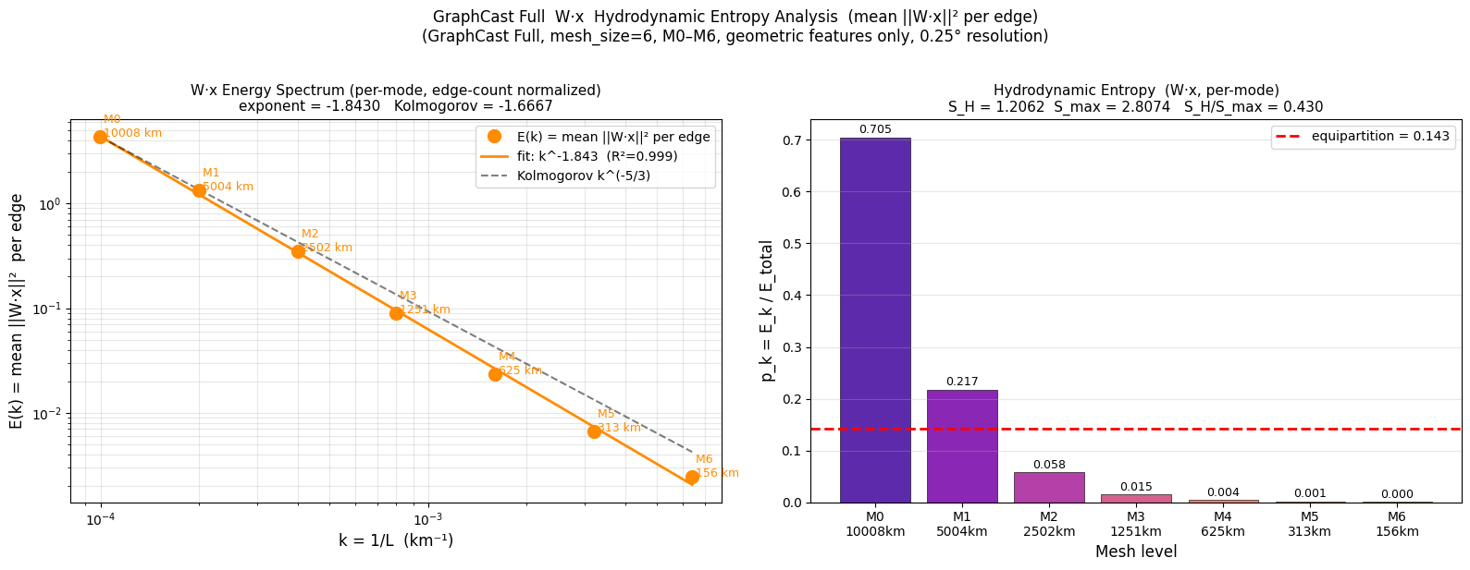
GC_Small
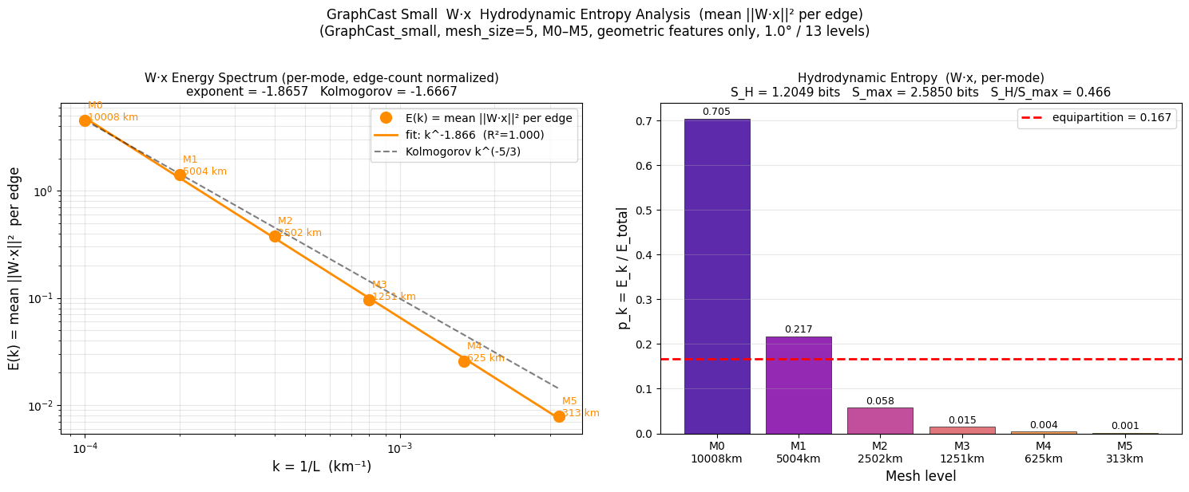
GC_Operational:

